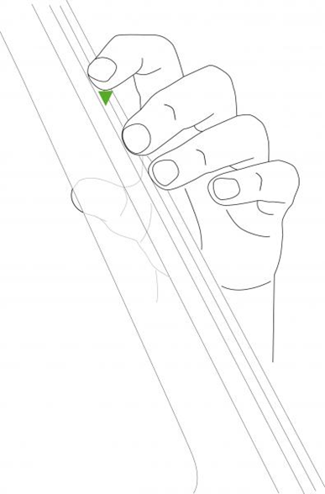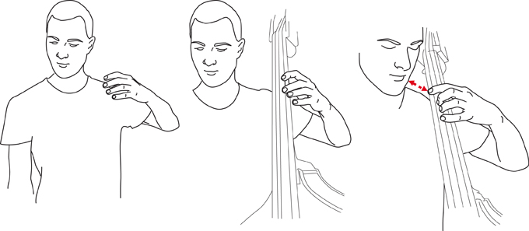

* Fingers on their tips
* The thumb should be opposite the middle two fingers
* There should be space in the palm of the hand
* Naturally straight wrist
* Elbow out away from the bass (like a chicken wing)