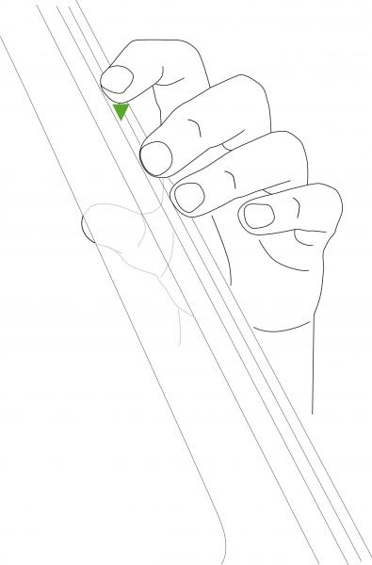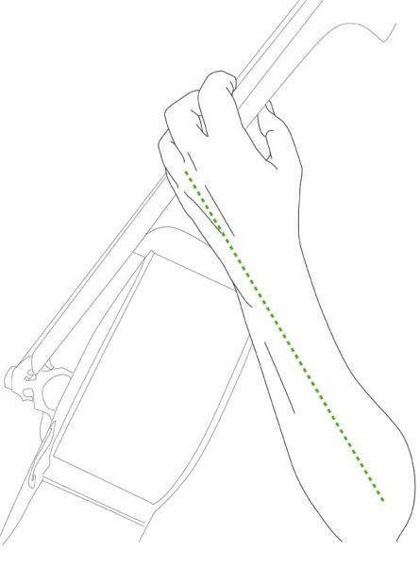

* Fingers on their tips
* The thumb should be opposite the middle two fingers
* There should be space in the palm of the hand
* Thumb on the middle of the back of the neck
* Naturally straight left wrist
* Elbow should be out away from the cello (like a chicken wing)