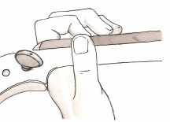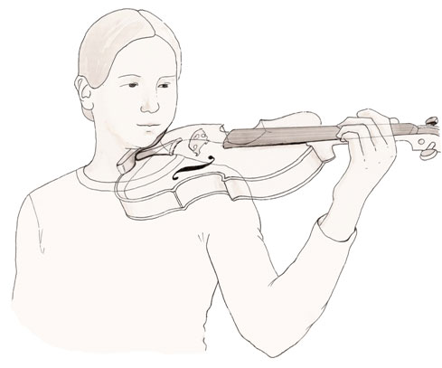

* Fingers should be on their tips
* Thumb should be on the side of the instrument with the fingernail even with the neck.
* There should be space between the thumb and the pointer knuckle
* Naturally straight left wrist
* Elbow should not rest on anything and should be free to move