Violins & Violas Bow Hold Checklist:

- Pinky on its tip on top of the bow
- First three fingers relaxed and curved over the bow and tilted

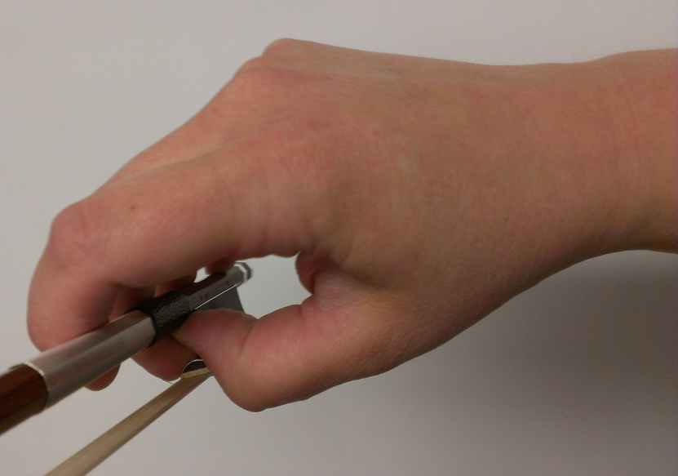
- Thumb on its tip, with the knuckle bent against the hair
- There is space in the palm of the hand, it should be curved and almost a circle
- Overall, the bow hold should be relaxed and flexible

